ЦЕНТР ПО САПРОПЕЛЮ
Астрахань. ул. Ульянова, 67. тел. +7(8512)732220. 592945. факс +7(8512)592838.
e-mail: danil@astranet.ru www.saprex.ru www.sapropex.ru

A new raw material and technology of production of ceramsite

Complex of measures on search and evaluation exploration raw — sapropelit (bottom silts of bogs and dying from siltation of water bodies), laboratory analyses, opinion on the suitability, feasibility study and design decision of changing the source of raw material of the existing enterprise ceramsite production from clay into more cheaper and available raw material — sapropelite (bottom sediments silted reservoirs, channels, riverbeds) with partial refurbishment of equipment or without, development of technology of preparation and processing of raw and its production mining at explored deposits. The main differ is: free obtaining raw materials (such as disposal of sludge) during ecological clean-water, low-cost production, transportation, reduction of production costs, quality indicators of the finished product.
Terms of preparation of the documentation: 4-5 months.
Price: from $ 40,000.00 USD

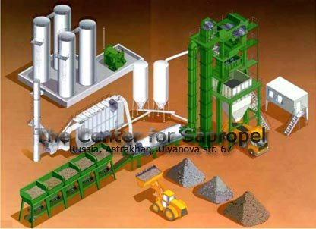

field research, sapropel, bottom sludge, quality, quantity, conclusion, feasibility studies, suitability, survey, evaluation, laboratory works, balance reserves, production, fertilizer,

recultivation, sorbents, peloids, therapeutical mud, cosmetics, feed additives

