ЦЕНТР ПО САПРОПЕЛЮ
Астрахань. ул. Ульянова, 67. тел. +7(8512)732220. 592945. факс +7(8512)592838.
e-mail: danil@astranet.ru www.saprex.ru www.sapropex.ru

Borehole hydraulic mining quartz sand

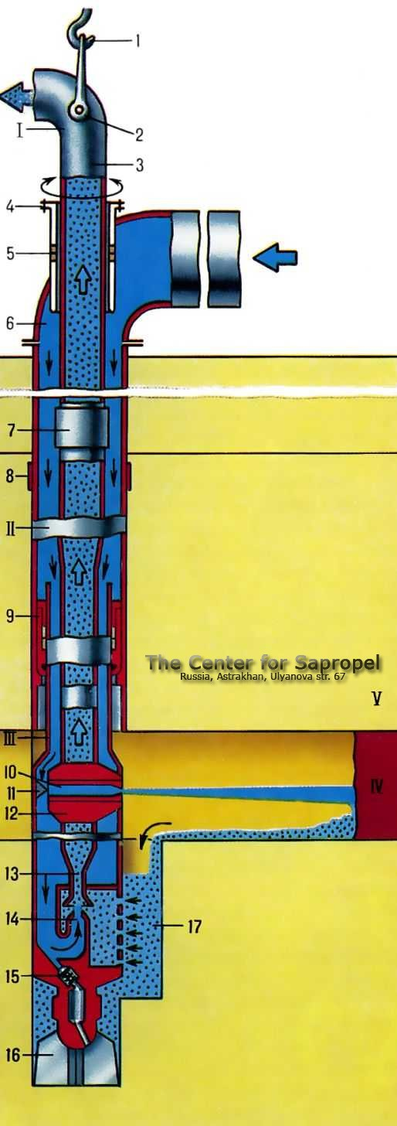
We perform complex preparatory works, feasibility studies, design and supply equipment for hydraulic borehole quartz sand in all kinds of fields and off-balance sheet fields with different depths of development, with the planting of the roof, keeping the surface terrain or working off camera without collapse of the overlying rocks. Economic efficiency of a method is much higher than quarry development. Keeping surface of the field. In the mining involve any volumes of deposits of sands. Terms of preparation and feasibility studies, project: 5-7 months. Price of the set of the borehole hydraulic mining with minimal equipment: from $ 300,322.00 USD

field research, sapropel, bottom sludge, quality, quantity, conclusion, feasibility studies, suitability, survey, evaluation, laboratory works, balance reserves, production, fertilizer,

recultivation, sorbents, peloids, therapeutical mud, cosmetics, feed additives

