ЦЕНТР ПО САПРОПЕЛЮ
Астрахань. ул. Ульянова, 67. тел. +7(8512)732220. 592945. факс +7(8512)592838.
e-mail: danil@astranet.ru www.saprex.ru www.sapropex.ru

Borehole mining of productive connate sludge and sapropel

Complex of works related to research the quantity and quality of productive layer of sapropel, feasibility study(TEO) and project for mining and processing, production of different range and types of packaging products. Advantages: compactness and mobility of the complex, development of sapropel in hard to reach areas, bogs, from under the non-productive layers, buried at a depth, paste-like, liquid, stable consistency. For the production of fertilizers and organic-mineral raw materials for recultivation, therapeutic and cosmetic mud, medical and veterinary applications, sorbents, sinks heavy and radioactive elements, fillers cat's toilet, feed additives for animals. Capacity: up to 176 m3/hour. Terms of research and configuration of the complex: up to 6 months.
Price: from $ 103,000.00 USD

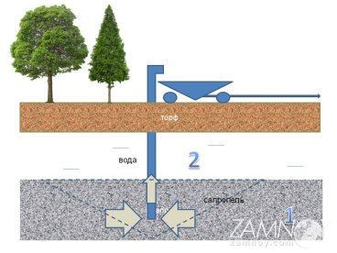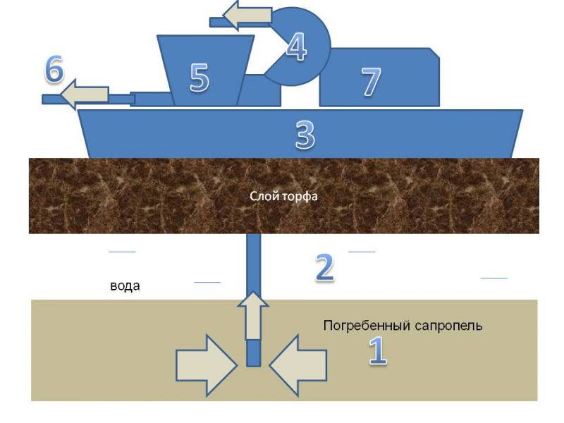

field research, sapropel, bottom sludge, quality, quantity, conclusion, feasibility studies, suitability, survey, evaluation, laboratory works, balance reserves, production, fertilizer,

recultivation, sorbents, peloids, therapeutical mud, cosmetics, feed additives

